ARYAMAN MISHRA

19BCE1027

1.Find greatest among 2 numbers using conditional operators.

#include<stdio.h>

main()

{

int a,b,big;

scanf("%d%d",&a,&b);

big=(a>b)?a:b;

if(big==a)

{

printf("%d is greater than %d",a,b);

}

else

{

printf("%d is greater than %d",b,a);

}

}

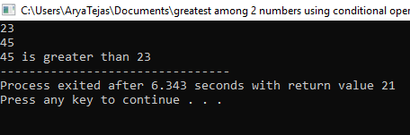

2.Check value of x and E.

#include<stdio.h>

main()

{

int x,E;

x=3;

E=(x==2)?1:0;

printf("%d",E);

printf("%d",x);

}

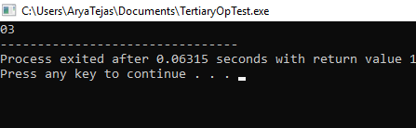

3.Program 2 using Tertiary Operator.

#include<stdio.h>

main()

{

int a,b,big;

scanf("%d%d",&a,&b);

big=(a>b)?printf("%d is greater than %d",a,b):printf("%d is greater than %d",b,a);

}



4.Write a C program to list all Prime Numbers for given N numbers.

10->2,3,5,7

15->2,3,5,7,11,13

#include<stdio.h>

main()

{

int n,i,x,j,c=0;

scanf("%d",&n);

for(i=1;i<=n;i++)

{

x=i;

for(j=1;j<=x;j++)

{

if(x%j==0)

{

c++;

}

}

if(c==2)

{

printf("%d,",x);

}

c=0;

}

}

